 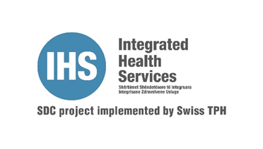

**Invitation to Tender 12.09.2024**

Reference: ITT/AQH/IHS/002/2024

Swiss Tropical and Public Health Institute (Swiss TPH), office in Kosovo is implementing project:” Accessible Quality Healthcare” (AQH) and “Integrated Health Services” to contribute for improvement of the health of population through excellence in research, services, teaching and training in Kosovo”

The Accessible Quality Healthcare (AQH) Integrated Health Services (IHS) Projects in Kosovo hereby invites eligible companies to submit their bids to provide following services:

**“Design, layout and printing of promotion materials for AQH and IHS Project needs”**

Interested companies can obtain tender documents by contacting the AQH Project Office in Prishtina, Kosovo, via e-mail address: [gani.surdulli@aqhproject.org](mailto:gani.surdulli@aqhproject.org) and send request for tender documentation. The tender documentation will be sent to requestor electronically/by email. All necessary documentation for application is included in the tender dossier.

The deadline for submitting bids is **03.10.2024** at **14:00** pm, address: Rr. Tirana, Prime Residence, C 4/3, Entrance D, 6`th floor, Flats no. 16, 17 & 18, 10000 Prishtina, Kosovo. Bids must be submitted in hard copy (one original and two copies + USB or CD), in sealed (one) envelope, to the AQH Project Office.

For additional information, please contact the SWISS TPH/ AQH Project at the following email address: [gani.surdulli@aqhproject.org](mailto:gani.surdulli@aqhproject.org)

SWISS TPH/AQH Project